

TASCO Motor Insurance Growth Platform · TGP-ARC-05
Deployment and Infrastructure Architecture
Date – 07 October 2026
Version – 1.0
Prepared by – iorta TechNXT
TABLE OF CONTENTS
1. Document Control 3
2. Acronyms 3
3. Introduction 5
3.1. Purpose 5
3.2. Scope 5
3.3. Audience 5
3.4. Related documents 5
4. Deployment principles 5
5. Hosting in Vietnam 6
6. Environments 7
7. Production topology 8
7.1. API deployment 9
7.2. Scheduled jobs 9
8. Network and edge 10
8.1. Network controls 10
8.2. Ingress and WAF 10
9. PostgreSQL 10
10. Configuration 11
11. Secrets management 12
12. Delivery pipeline 13
13. Release strategies 15
14. UAT and local environments 15
15. Capacity and sizing 15
15.1. Assumptions 15
15.2. Storage, year one 16
15.3. Throughput 16
15.4. Sizing by environment 16
16. Resilience and disaster recovery 17
17. Observability 17
18. Appendix 18
18.1. Kubernetes manifests 18
19. Sign-Off 19

Document Control

Date | Version | Author & Business Unit Info | Reviewed By & Business Unit Info | Approved By & Business Unit Info | Change History
07/10/2026 | 1.0 | iorta TechNXT  Solution Architecture | TASCO Insurance  IT Infrastructure | TASCO Insurance  Programme Sponsor | Initial issue for submission

Acronyms

Acronym / Symbol | Definition / Meaning
API | Application programming interface
BI | Business intelligence
CAB | Change advisory board
CDN | Content delivery network
CI | Continuous integration
CPU | Central processing unit
DNS | Domain Name System
DR | Disaster recovery
HSTS | HTTP Strict Transport Security
HTTPS | Hypertext Transfer Protocol Secure
IOPS | Input/output operations per second
IP | Internet Protocol
IT | Information technology
JSON | JavaScript Object Notation
KMS | Key management service
MFA | Multi-factor authentication
mTLS | Mutual Transport Layer Security
OWASP | Open Worldwide Application Security Project
PITR | Point-in-time recovery
SBOM | Software bill of materials
SIT | System integration testing
SMS | Short message service
SSD | Solid-state drive
SSH | Secure Shell
SSO | Single sign-on
TLS | Transport Layer Security
UAT | User acceptance testing
URL | Uniform resource locator
UTC | Coordinated Universal Time
vCPU | Virtual central processing unit
VETC | Vietnam Electronic Toll Collection
WAF | Web application firewall
WAL | Write-ahead log

Introduction

Purpose
This document describes how the TASCO Growth Platform is built, deployed and run: the environments, the production topology in Vietnam, the Kubernetes workloads and scheduled jobs, network and ingress controls, PostgreSQL high availability, configuration and secrets, the delivery pipeline, release strategies, capacity, resilience and observability.

Scope
The deployment assets in the repository (Dockerfile, docker-compose.yml, deploy/k8s/, railway.json and .github/workflows/ci.yml) and the production design they implement. Where a value in this document differs from a manifest, the manifest is what is deployed and a change is raised to bring the two back in line.

Audience
TASCO IT infrastructure and operations, information security, the platform and site reliability engineers of iorta TechNXT, and TASCO finance for the sizing sections.

Related documents
ID | Title | Relationship
TGP-ARC-01 | Solution Architecture | Runtime processes and quality targets
TGP-ARC-04 | Security Architecture | Trust boundaries, secrets and pipeline controls
TGP-ARC-07 | Architecture Decision Records | ADR-012 containers and Kubernetes
TGP-OPS-01 | Runbook and Support Guide | Day-to-day operation
TGP-OPS-02 | Monitoring and Alerting | Dashboards and alert rules
TGP-OPS-03 | Disaster Recovery and Business Continuity Plan | Recovery tiers, failover and drills
TGP-OPS-06 | Release and Change Management | Release process and change control
TGP-QA-03 | Performance and Capacity Test Plan | Capacity validation

Deployment principles
Principle | Application
One immutable artefact | The same image, pinned by digest, is promoted from SIT to production and DR. Only configuration differs. The hosted UAT builds the same Dockerfile from the same commit.
Twelve-factor processes | Configuration from the environment and secrets from mounted files; JSON logs on standard output; stateless processes with state in PostgreSQL; API and jobs share one image with different commands.
Least privilege | Containers run as the image’s non-root node user (uid 1000) with a read-only root file system, all Linux capabilities dropped and the default seccomp profile. Network policy denies by default. The database has separate owner and application roles.
Fail safe | Production refuses to start without its secrets or a database, or with demo mode on. Readiness stays false until the database answers. On shutdown the pod drops readiness first, drains and exits within 25 seconds.
Data residency | Production personal data is stored and processed in Vietnam (to be confirmed by TASCO legal under the Cybersecurity Law 2018, Decree 53/2022/ND-CP, Decree 13/2023/ND-CP and the Law on Personal Data Protection 2025).

Hosting in Vietnam
Production is hosted in Vietnam on a managed Kubernetes service and a managed PostgreSQL service from a local cloud provider (for example Viettel IDC, VNG Cloud or FPT Cloud), or on TASCO’s or the Tasco group’s private cloud if preferred. The choice is confirmed in discovery against TASCO’s data-residency position and existing contracts. The platform is containerised and uses standard Kubernetes and PostgreSQL features, so it is not tied to a provider. If no managed PostgreSQL option meets residency, PostgreSQL runs on Kubernetes with an operator such as CloudNativePG, or on virtual machines with Patroni.

Environments
Environment | Purpose | Hosting | Data | Integrations | Promotion gate
Development | Daily engineering | Laptop: Docker Compose, or in-memory store | Synthetic | Sandbox adapters | None
CI | Automated tests on every change | GitHub Actions with a PostgreSQL service container | Synthetic | Sandbox | All checks pass
UAT (live) | Business acceptance and training | Railway with Railway PostgreSQL | Synthetic only | Sandbox adapters, simulated TASCO core | Product owner approval
SIT | Integration with TASCO and VETC test systems | Kubernetes namespace in the production provider | Synthetic plus provider test accounts | Real adapters to provider sandboxes | Automatic on merge
Pre-production | Performance, soak, resilience and security tests; release rehearsal | Namespace sized like production | Masked or synthetic at 6 million scale | Sandbox with fault injection, or provider test systems | Performance report signed off
Production | Live service | Managed Kubernetes in Vietnam, three zones | Real, encrypted | Production providers | CAB approval and change window
DR | Warm standby | Second Vietnamese region or data centre | Replica of production | Production providers | DR drill twice a year

The hosted UAT runs at https://tasco-growth-api-uat.up.railway.app with demo mode on, which enables demonstration sign-in helpers, simulated dates and the seed job. Its password is distributed in the access workbook and never written in documents. SIT, pre-production, production and DR run in production mode with demo mode off; the Kubernetes configuration sets both, and production refuses to start otherwise.

Production topology
The diagram shows the production deployment in one Vietnamese region. Customers, staff and partners reach the platform through the WAF; the API pods and the scheduled jobs share one PostgreSQL cluster; all outbound calls leave through the egress proxy.
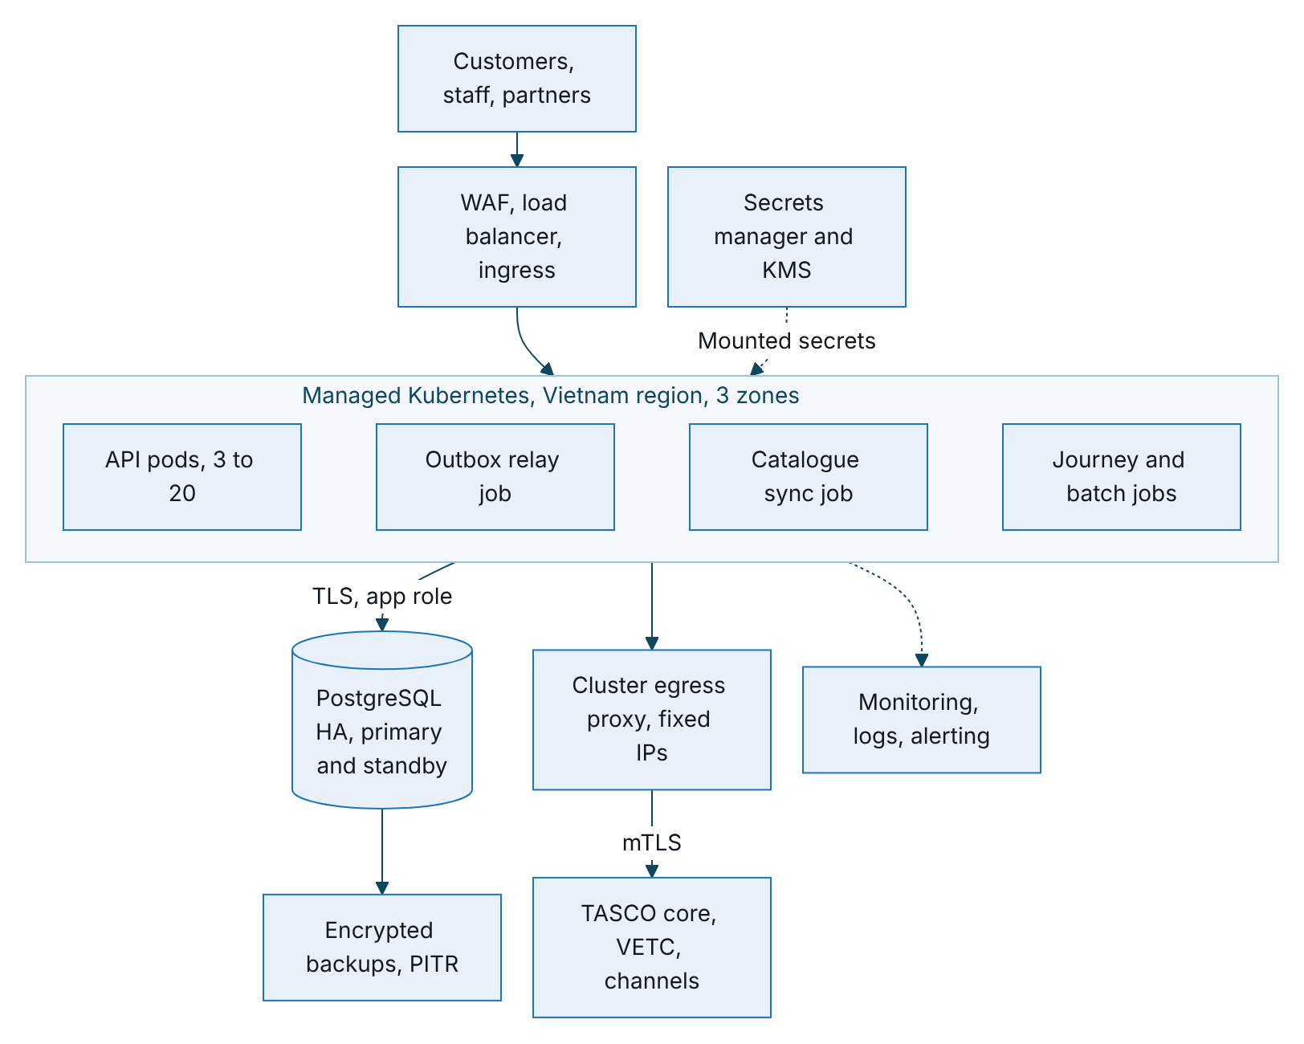
Figure 1 – Production topology in one Vietnamese region
The outbox relay runs in two places: every API pod relays pending events once a second, and the relay job drains anything left every five minutes as a safety net. A read replica for reporting and a cross-region replica for DR are described in section 7 and section 14.

API deployment
Item | Setting
Image | tasco-growth-platform, pinned by digest
Command | node src/server.js
Replicas | 3, spread across zones; autoscaler from 3 to 20 on CPU (65%) and memory (75%); scale-down stabilisation 300 s
Resources | Request 250m CPU and 256 MiB; limit 1 CPU and 512 MiB; Node heap 384 MiB
Probes | Liveness /health/live every 10 s; readiness /health/ready every 5 s with a database check; start-up allowance 60 s
Security context | Non-root uid 1000, read-only root file system, no privilege escalation, all capabilities dropped, default seccomp, no service account token
Writable paths | /tmp only (64 MiB)
Disruption | Pod disruption budget of at least 2 available; rolling updates with no unavailable pod
Termination | 30 s grace period; the application forces exit at 25 s
The image has no init process; the server handles termination signals itself.

Scheduled jobs
All jobs run the same image with node src/jobs/cli.js <job>, never overlap (concurrencyPolicy: Forbid) and retry once. Schedules are set in UTC; the table shows Vietnam time.
Job | Vietnam time | What it does
journeys | 08:15 daily | Runs all due touchpoints inside the 08:00 to 20:00 contact window; steps blocked only by the window stay scheduled
recompute | 00:30 daily | Re-scores all leads so time-dependent facts move on
sync-catalogue | 01:00 daily | Fetches TASCO core’s product catalogue and proposes changes for maker-checker approval; never activates them
reconcile | 02:00 daily | Flags completed orders without payment reference or policy, stuck payments, failed payments and failed compensations
retention | 03:00 daily | Deletes source records after 365 days and call sessions after 180 days; other entities go to the archival pipeline
relay | Every 5 minutes | Drains the event outbox as a safety net for the in-pod relay
migrate | Before each release | Applies database migrations under an advisory lock
Job outcomes are recorded in the job history (visible in the staff console) and in the logs. Failed jobs raise an alert from the Kubernetes job metrics. Journey runs can be added hourly within the contact window if volumes require it.

Network and edge

Network controls
Network zones and trust boundaries are described in TGP-ARC-04 Security Architecture. The table lists how they are enforced in the cluster.
Control | Implementation
Default deny | Network policy with no ingress or egress in the application namespace, then allow-lists: ingress from the ingress controller and monitoring to port 8080; egress to the PostgreSQL subnet on 5432, DNS and the egress proxy on 3128
Workload identity | Separate service accounts for the API, each job and migrations, with no token mounted; the migrator owns the schema and the application role has data rights only
Encrypted connections | TLS to PostgreSQL with certificate verification; mTLS to providers through the egress proxy
Administrative access | No SSH to nodes; cluster access through SSO with MFA and just-in-time roles; database break-glass through a bastion with session recording
Service mesh | Optional, for pod-to-pod mTLS if more services are added

Ingress and WAF
Control | Setting
TLS | TLS 1.2 or higher (1.3 preferred) with modern ciphers; certificates from cert-manager; HSTS also set by the application
Client address | The application takes the client IP from the right-most trusted forwarded hop (TRUST_PROXY_HOPS, one hop by default, two with a CDN in front)
Rate limiting | 50 requests per second per client IP at the ingress, shared across pods; stricter limits for sign-in and customer session at the gateway; per-partner quotas at the gateway. The in-process limiter (300 per minute, 10 sign-ins per minute per IP) is a per-pod second line.
Body size | 1 MiB
Path rules | Metrics blocked from outside the cluster; the API description and staff APIs can be restricted to TASCO and VETC corporate addresses
WAF | ModSecurity with the OWASP core rule set, paranoia level 2 on the API, tuned for rule payloads; bot management on customer and public endpoints
Partner mTLS | Target: a separate partner host with client certificate verification

PostgreSQL
Aspect | Design
Service | Managed PostgreSQL 16 in a Vietnamese region
High availability | Primary with a synchronous standby in another zone; automatic failover in about 30 to 60 seconds. The connection pool reconnects; failed requests return 5xx and idempotent retries are safe.
Backups | Continuous WAL archiving and daily base backups, encrypted with the KMS; point-in-time recovery for 35 days; monthly snapshots kept 12 months; restore tested quarterly
Read replica | Asynchronous replica for dashboards, BI extracts and analytics feeds
DR | Cross-region asynchronous replica, promoted in a declared disaster
Connections | Pool of 10 per process; with 20 API pods and the jobs that is about 260 connections, so a transaction-mode connection pooler sits in front
Parameters | Statement timeout 15 s (set by the application); idle-in-transaction timeout 60 s; slow-query log from 500 ms; query statistics enabled
Roles | Owner role for migrations, tables and triggers; application role with data rights and insert and select only on the audit log, no truncate or schema rights; read-only role for the replica
Encryption | Storage encryption with the KMS; TLS enforced; personal fields additionally encrypted by the application
Partitioning | Messages, touchpoints and domain events partitioned by month at scale, through a new numbered migration

Configuration
All settings are read by src/shared/config.js. Non-secret values sit in a configuration map; secrets are mounted files referenced by <NAME>_FILE.
Setting | Default | Production
NODE_ENV | development | production
PORT | 3000 | 8080
PUBLIC_BASE_URL | Local address | The platform’s public address, used in links and certificate URLs
DATABASE_URL (file) | In-memory store outside production | Required
DATABASE_SSL, DB_POOL_MAX | On in production, 10 | true, 10
JWT_SECRET (file) | Random in development | Required, at least 48 random bytes
JWT_TTL_SECONDS | 1,800 | 1,800
MFA_REQUIRED_ROLES | Administrator, rule approver, compliance officer, data steward | Add telesales supervisor, partner manager, support engineer (recommended)
DATA_KEYS, DATA_KEY_ACTIVE (file) | Random development key | Required; explicit active key
BLIND_INDEX_KEY (file) | Random in development | Required, 32 bytes
RATING_SOURCE | rules | core or core_with_fallback, as TASCO decides
TASCO_CORE_BASE_URL | Empty (simulated core) | TASCO core API gateway, HTTPS
TASCO_CORE_CLIENT_ID, TASCO_CORE_CLIENT_SECRET (file) | Empty | Required when the core address is set
TASCO_CORE_TOKEN_URL, TASCO_CORE_SCOPE | Core address plus /oauth2/token; rating and product scopes | As agreed with TASCO core
TASCO_CORE_TIMEOUT_MS | 5,000 | 5,000
ALLOW_LOCAL_RATING | false | false
CORS_ORIGINS | Same origin only | VETC and Zalo origins only if they call cross-origin
RATE_LIMIT_MAX, RATE_LIMIT_LOGIN_MAX | 300, 10 per minute | Keep; the edge enforces global limits
LOCKOUT_MAX_FAILURES, LOCKOUT_MINUTES | 5, 15 | Keep
TRUST_PROXY, TRUST_PROXY_HOPS | On in production, 1 | true, number of proxies in front
METRICS_TOKEN (file) | Unset | Required
LINK_TTL_DAYS | 30 | 30
MIGRATE_ON_START | Runs unless false | false; the migration job runs instead
DEMO_MODE and UAT demo settings | Off, unset | Off and unset

Secrets management
Secrets are created in the secret store, synchronised into the cluster and mounted into pods as read-only files. The diagram shows the path.
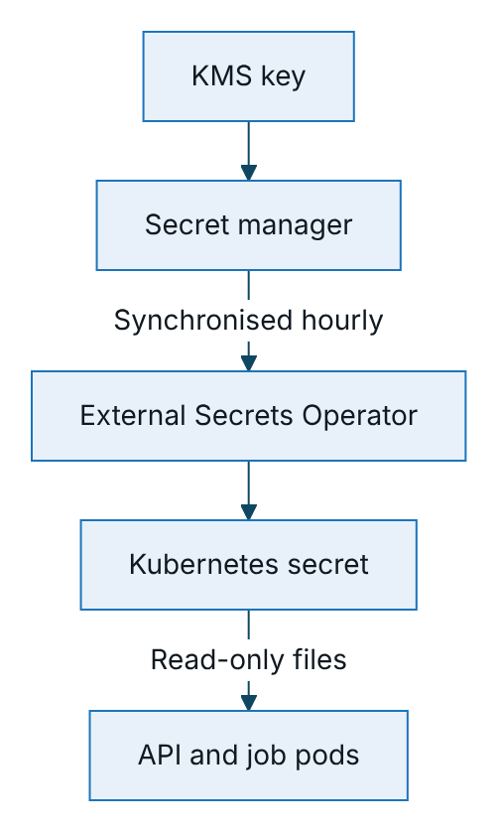
Figure 2 – Path of a secret from the KMS key to the pods
Secret | Rotation | Procedure
Data keys | Yearly or on suspicion | Add a new key, make it active, restart, run the re-key job (planned), remove the old key after verification
Token secret | Every 90 days | Rotation ends all sessions and unexpired renewal links; schedule out of hours until multi-key verification or identity provider tokens are in place
Blind-index key | Only on compromise | Recompute the phone index (planned job)
Database credentials | 30 to 90 days | Dynamic credentials from the secret manager where possible
TASCO core and provider credentials | Per provider policy | Mounted files, read at start-up; restart to rotate
Partner API keys | At most 12 months | Issue a new key, partner switches, revoke the old key
No secret is placed in images, Git, configuration maps or environment literals in Kubernetes. Secret scanning runs on every change.

Delivery pipeline
Every change passes the same pipeline before it can reach production. The diagram shows the stages; TGP-ARC-04 Security Architecture lists the security gates and TGP-OPS-06 Release and Change Management the approvals.
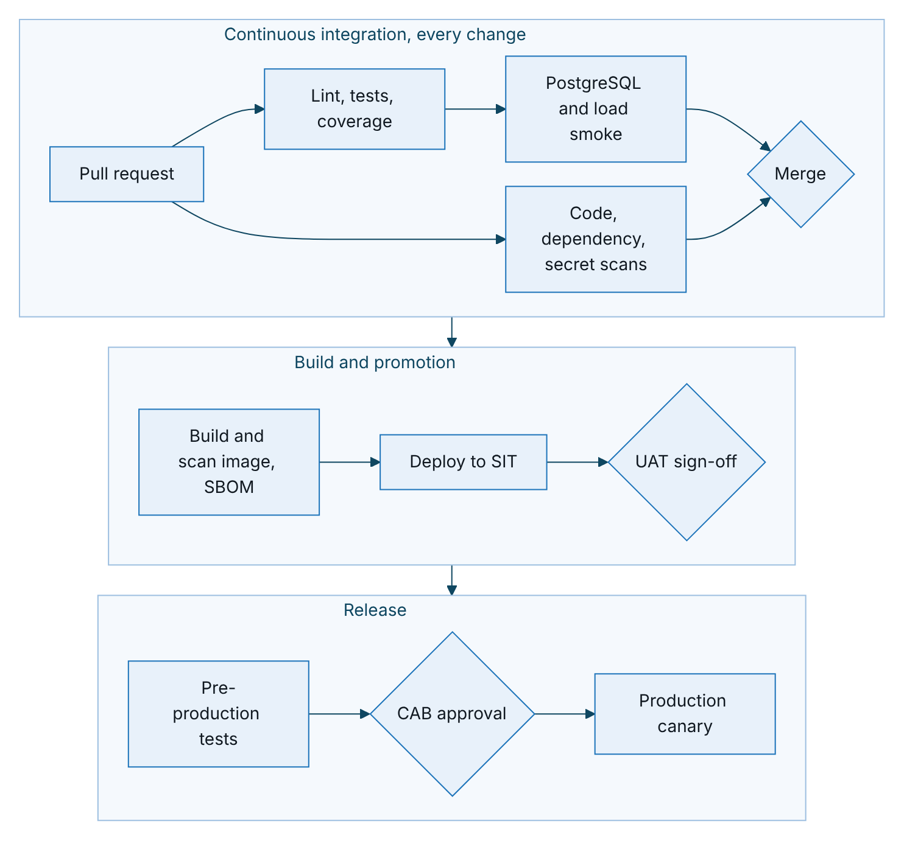
Figure 3 – Delivery pipeline from pull request to production canary
Stage | Gate
Lint, tests, coverage | Any failure; coverage below 80% lines, 70% branches or 80% functions; OpenAPI drift
PostgreSQL and load smoke | Any failure; 95th percentile budget exceeded
Code, dependency and secret scans | New high or critical static analysis finding; high or above dependency finding; any secret
Image | Fixable high or critical vulnerability; image running as root; missing SBOM; high dynamic scan alert
SIT | Health, sign-in with MFA, and quote, send and customer payment with provider test accounts
Production | Signed image digest only (admission policy, target); CAB ticket reference
Promotion is GitOps: the pipeline records the new image digest in the environment’s configuration and the cluster reconciles itself. The pipeline never applies changes to production directly.

Release strategies
Strategy | When | How
Rolling (default) | Backward-compatible code and configuration | One extra pod at a time, none unavailable, readiness-gated
Canary | Behaviour changes to journeys or purchase | Traffic split 5%, 25%, 100%, with automated checks on error rate, latency, integration errors and completed orders
Blue-green | Database-affecting or major releases | Two deployments; switch after smoke tests. Database changes follow expand and contract.
Three points are specific to this platform. The outbox relay runs in every pod, including canary pods, so event handler changes must stay backward compatible or use a new event type. Scheduled jobs are updated in the same release, after the API rollout succeeds. Rule changes are data, not deployments: they go through maker-checker, not the release process, and reach every pod within 15 seconds.

UAT and local environments
The live UAT runs on Railway from the same Dockerfile: start command node src/server.js, migrations as a pre-deploy command, health check on /health/ready, restart on failure, two replicas, Railway PostgreSQL. Secrets are Railway variables, because Railway does not mount files. Railway has no network policy and is hosted outside Vietnam, so it holds synthetic data only and is not used for production personal data (to be confirmed by TASCO legal).
Locally, Docker Compose runs the application and PostgreSQL 16 with demo data and local-only secrets. Without Compose, the application runs on the in-memory store and needs no database.

Capacity and sizing

Assumptions
These assumptions are validated in pre-production (TGP-QA-03 Performance and Capacity Test Plan).
ID | Assumption
A1 | 6.0 million vehicles and about 7.8 million source records
A2 | Expiries spread evenly: about 16,400 vehicles reach expiry each day
A3 | About 30% of vehicles in an active journey; about 5 sends per expiring vehicle
A4 | Voice assistant used for about 20% of expiring vehicles: about 3,300 calls a day
A5 | About 15% of expiring vehicles buy through the platform: about 2,500 orders a day
A6 | About 300 staff users, mostly telesales; customer traffic peaks after push waves

Storage, year one
Data | Rows | Size
Profiles and leads | 6 million each | About 40 GB with indexes
Source records | 7.8 million | About 11 GB with indexes
Touchpoints | About 7 million live, 42 million executed a year | About 30 GB a year before purging
Messages | About 30 million a year | About 24 GB a year
Call sessions | About 1.2 million a year, 180-day retention | About 2.5 GB steady
Quotes, orders, policies | About 2.7, 0.9 and 1.1 million a year | About 10 GB a year
Audit trail | About 18 million entries a year | About 7 GB a year
Total |  | About 120 to 130 GB; provision 500 GB with automatic growth

Throughput
Workload | Estimate | Implication
API | 10 to 20 requests per second normally; about 150 for 15 minutes after a push wave | Three pods are ample: one process sustained 337 requests per second (95th percentile 103 ms, no errors) in the load smoke
Journey runs | About 115,000 touchpoint evaluations a day | 15 to 25 minutes per run with providers at 100 ms; parallel workers and asynchronous calls are needed before full scale
Nightly re-scoring | 6 million profiles | Sharded workers with keyset paging to finish in about an hour
Orders | About 2,500 a day, peak about 1 per second | Bound by wallet and core latency
Audit appends | About 50,000 a day, peak about 20 per second | Well within serialised append capacity
Production database sizing: primary of 8 vCPU, 32 GB memory and 500 GB SSD (at least 6,000 IOPS) with a standby of the same size, and a read replica of 4 vCPU and 16 GB. The working set of profile, lead and touchpoint indexes, about 10 GB, fits in memory.

Sizing by environment
Environment | API | Jobs | PostgreSQL
SIT | 2 pods | On demand | 2 vCPU, 8 GB, single zone, 7-day recovery
Pre-production | 3 to 20 pods | Sharded workers | 8 vCPU, 32 GB, only during test windows
Production | 3 pods baseline, up to 20 | About 5 pod-hours a day | Primary and standby 8 vCPU, 32 GB; replica 4 vCPU, 16 GB
DR | 0 or 1 warm pod, scaled on failover | None until failover | Asynchronous replica 4 vCPU, 16 GB
At scale, per-message channel costs outweigh infrastructure costs; the next-best action prefers push over Zalo over SMS over voice over telesales. Purging or partitioning high-churn tables and running reporting on the replica keep the database on a smaller tier.

Resilience and disaster recovery
Measure | Target
Availability of the customer purchase path | 99.9% monthly
Recovery point objective | 15 minutes or less
Recovery time objective | 4 hours or less
Backups | Encrypted, point-in-time recovery for 35 days, restore tested quarterly
Application | At least two replicas across zones (three in the manifests), rolling deployments, pod disruption budget
The design is expected to do better than these targets in most failures: a zone failure is absorbed by the synchronous standby with no data loss and automatic failover, and a region loss is recovered from the cross-region replica with a few minutes of data loss. DR uses a warm standby: manifests are kept in step by GitOps with replicas at zero or one, and the database replica runs in the DR region. Failover promotes the replica, points the database secret at it, scales up the API and jobs, switches DNS and verifies health, the audit chain and the outbox backlog. Providers are told the DR egress addresses in advance. TGP-OPS-03 Disaster Recovery and Business Continuity Plan holds the recovery tiers, procedures and drill schedule.

Observability
Signal | Design
Logs | One JSON object per line with time, level, message and service; personal and secret keys redacted; every API request logged with request id, route, status and duration. Kept 30 days online and one year in archive.
Metrics | Prometheus format at /metrics, inside the cluster only and protected by a token: request latency and counts by route and status, integration calls and short circuits, events published and processed, messages by channel and status, quotes, orders, compensations, calls by outcome, core rating results and indicative quotes
Alerts | Availability burn rate, latency, open circuit on wallet or core, dead-letter events, outbox lag, sign-in anomalies, reconciliation mismatches, audit-chain probe failure, job failure
Tracing | Request ids today, accepted from the caller or generated, echoed in responses and logs. OpenTelemetry tracing with propagation to providers and into events is planned for the scale phase.
Short-lived job pods are not scraped; their results are in the job history and logs. An outbox backlog gauge and database pool metrics are planned. TGP-OPS-02 Monitoring and Alerting defines the dashboards and alert rules.

Appendix

Kubernetes manifests
File | Contents
00-namespace.yaml | Application namespace
10-configmap.yaml | Non-secret settings, including production mode, demo mode off, RATING_SOURCE=core and the TASCO core address
15-external-secret.yaml | Synchronisation of secrets from the secret store
20-deployment.yaml | API deployment, probes, resources, security context, zone spread
30-service-ingress.yaml | Service and ingress with TLS, WAF rules, body limit and edge rate limit
40-hpa-pdb.yaml | Autoscaler (3 to 20) and disruption budget (at least 2)
50-networkpolicy.yaml | Default deny and allow-lists
60-jobs.yaml | Migration job and the six scheduled jobs
kustomization.yaml | Assembly of the above

Sign-Off
Serial Number | Description | Owner | Status
1 | Hosting provider in Vietnam (managed Kubernetes and managed PostgreSQL) or TASCO private cloud | TASCO IT Infrastructure | Open
2 | Data residency position for production and backups | to be confirmed by TASCO legal | Open
3 | Private connectivity to TASCO core and VETC (VPN or private link) and fixed egress addresses | TASCO IT and VETC | Open
4 | Secret store and key management service | TASCO Information Security | Open

Sign Off Date | Signature | Approved By | Department & Project Role
 |  | TASCO Insurance | Programme Sponsor
 |  | TASCO Insurance | IT Infrastructure
 |  | iorta TechNXT | Solution Architecture



